**Exercise**

* **Write a program to convert Kilometres to miles.**

**Approach:**

**So here we did like this**

**Take the km as an input and multiply with 0.621371**

**miles = km*0.621371**

**Solution 👇**

**Java :**

**import java.util.Scanner;**

**public class CodeXam {**

**public static void main(String[] args) {**

**System.out.println("Enter the value in kilometers");**

**Scanner sc = new Scanner(System.in);**

**double km = sc.nextDouble();**

**System.out.println();**

**double miles = km*0.621371;**

**System.out.println("The value in miles is  "  +  miles  +  "  miles");**

**}**

**}**

**output:**

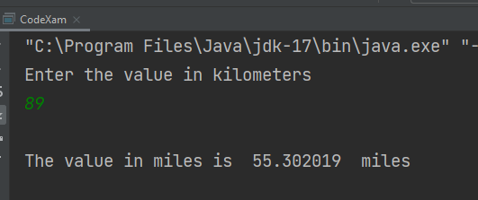

**Python :**

**value_in_km = int(input("Enter the value in kilometers: \n"))**

**km_to_miles = (value_in_km * 0.621371)**

**print("The value in miles is : \n", km_to_miles)**

**output:**

